

***W2*** *PRACTICE*

*Native HTTP and Manual Routing*

# At the end of this practice, you can



* **Create** and run a native Node.js HTTP server
* **Manually implement** route handling using conditionals.
* Serve **static files** using fs.
* Parse form data from POST requests.
* Debug and enhance server code using console outputs.

# Get ready before this practice!



* **Read** the following documents to understand Nodejs built-in HTTP module:

https://nodejs.org/api/http.html

* **Read** the following documents to understand Anatomy of an HTTP Transaction:

https://nodejs.org/en/learn/modules/anatomy-of-an-http-transaction

# How to submit this practice?



* + Once finished, push your **code to GITHUB**
  + Join the **URL of your GITHUB** repository on LMS



* Identify and fix the bug.
* Understand the request-response cycle in Node.js using the http module.
* Explain the role of res.write() and res.end() in sending data back to the client.

For this exercise, you are provided with a minimal server.js file. Read and run the code and observe how it behaves.



// server.js

const http = require('http');

const server = http.createServer((req, res) => { res.write('Hello, World!');

return res.endd();

});

server.listen(3000, () => {

console.log('Server running on http://localhost:3000');

});

**Q1 –** What error message do you see in the terminal when you access

http://localhost:3000? What line of code causes it?

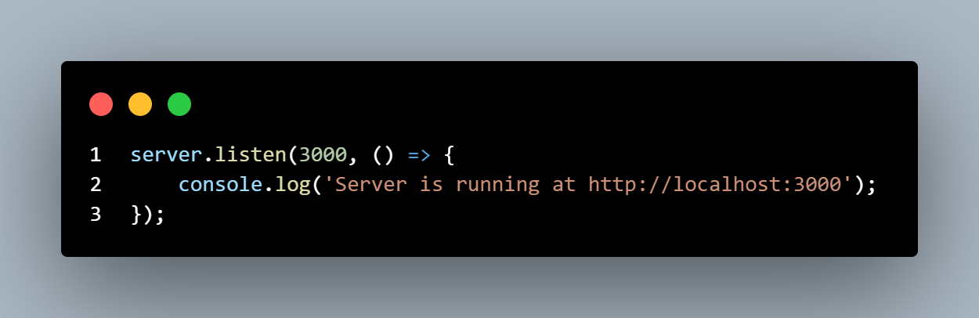

**Q2 –** What is the purpose of res.write() and how is it different from res.end()?

**Q3 –** What do you think will happen if res.end() is not called at all?

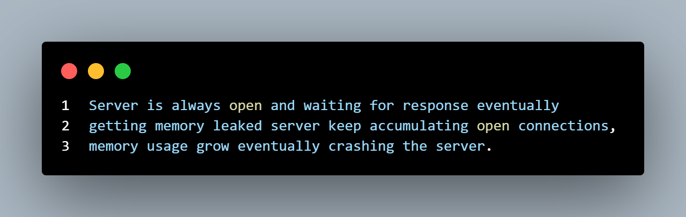

**Q4 –** Why do we use http.createServer() instead of just calling a function directly?

**http.createServer() is used because it's specifically designed to handle HTTP protocols and create a proper web server**

**Q5 –** How can the server be made more resilient to such errors during development?

**A Node.js server can be made more resilient during development by implementing try-catch blocks, global error handlers, using development tools like nodemon for auto-restart, adding proper logging mechanisms, and implementing request timeouts and graceful shutdown procedures.**

* Practice using req.url and req.method.
* Understand how manual routing mimics what frameworks (like Express) automate.
* Serve both plain text and raw HTML manually.

For this exercise you will start with a **START CODE (EX-2)**



**TASK 1 -** Update the code above to add custom responses for these routes:

|  |  |  |
| --- | --- | --- |
| **ROUTE** | **HTTP METHOD** | **RESPONSE** |
| /about | **GET** | About us: at CADT, we love node.js! |
| /contact-us | **GET** | You can reach us vai email… |
| /products | **GET** | Buy one get one… |
| /projects | **GET** | Here are our awesome projects |

Use VS Code’s Thunder Client (or other tools (POSTMAN, INSOMIA) of your choice or curl on your terminal to make request.

Example output

curl http://localhost:3000/about --------------------------> About us: at CADT, we love node.js!

curl http://localhost:3000/contact-us -------------------------

-> You can reach us vai email…

**TASK 2 –** As we can see the complexitiy grow as we add more routes. Use switch statement to arrange the code into more organized structure.

### ❓ Reflective Questions



* 1. What happens when you visit a URL that doesn’t match any of the three defined?

Return as 404 not found as default

* 1. Why do we check both the req.url and req.method?

We check both req.url and req.method because the same URL endpoint can handle different operations based on the HTTP method - like how "/contact" with GET shows a form while POST handles form submission. This follows REST principles where methods define the action (GET reads, POST creates, PUT updates, DELETE removes) even when targeting the same resource URL.

* 1. What MIME type (Content-Type) do you set when returning HTML instead of plain text?

When returning HTML instead of plain text, you set the MIME type to 'text/html' in the Content-Type header

* 1. How might this routing logic become harder to manage as routes grow?

As routes grow, manual routing becomes harder to manage because you need to handle more complex URL patterns, nested routes, route parameters, middleware, authentication, and HTTP methods - all within a single switch/if-else block. This leads to messy, hard-to-maintain "spaghetti code" that frameworks like Express solve with organized routing structures.

* 1. What benefits might a framework offer to simplify this logic?

A framework simplifies routing by providing organized route definitions, middleware support, and built-in features that would be complex to implement manually.

* Practice handling POST requests.
* Parse URL-encoded form data manually.
* Write and append to local files using Node.js' fs module.
* Handle async operations and errors gracefully.

For this exercise you will start with a **START CODE EX-3**



**TASK 1 -** Extend your Node.js HTTP server to handle a **POST request** submitted from the contact form. When a user submits their name, the server should:

1. **Capture the form data** (from the request body).
2. **Log it to the console**.
3. **Write it to a local file** named submissions.txt.

Testing, go to /contact on broswer and test

**Requirements**

* + Handle POST /contact requests.
  + Parse raw application/x-www-form-urlencoded data from the request body.
  + Write the name to a new line in submissions.txt.
  + Send a success response to the client (HTML or plain text).

## ❓ Discussion Questions

1. Why do we listen for data and end events when handling POST?
2. What would happen if we didn’t buffer the body correctly?
3. What is the format of form submissions when using the default browser form POST?
4. Why do we use fs.appendFile instead of fs.writeFile?
5. How could this be improved or made more secure?

## Bonus Challenge (Optional)

* + Validate that the name field is not empty before saving.
  + Send back a small confirmation HTML page instead of plain text.
  + Try saving submissions in JSON format instead of plain text.